**Sunkari Manohar**

**Aditya Institute of Technology and Management**

**Assessment 2 - 05/12/23**

**Infrastructure of Application:**

* Web Server
* App Server
* Database

**RDBMS:**

Relational database contains data in form of tables.

**SQL Commands:**

1. **DDL (Data Definition Language) commands**

* Create
* Drop
* Alter
* Truncate
* Rename
* Comment

### DML (Data Manipulation Language) commands

* 1. insert
  2. Update
  3. delete

1. **DCL (Data Control Language) commands**
   1. Grant
   2. revoke
2. **DQL (Data Query Language) commands**
   1. Select
3. **TCL (Transaction Control Language) commands**
   1. Commit
   2. Save point
   3. Roll back

**SQL commands implementation:**

First we created a database named “pet adoption” and then we used it.

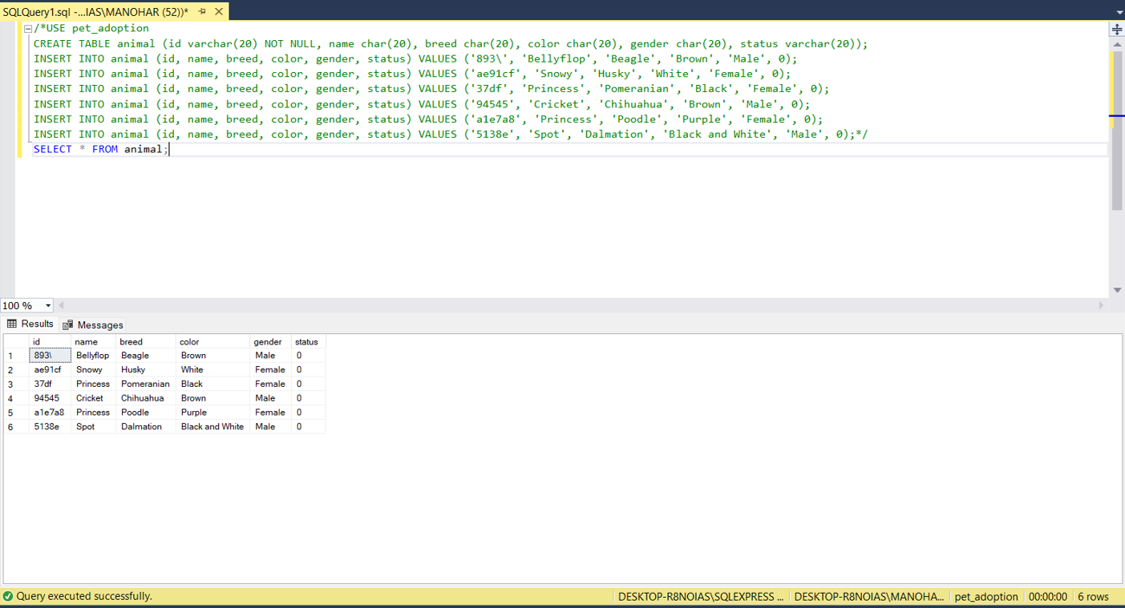

Created a table called ANIMAL and inserted values into it, using **insert** statement.

We can view the table using SELECT statement.

Displaying all the details from animal table using WHERE clause : 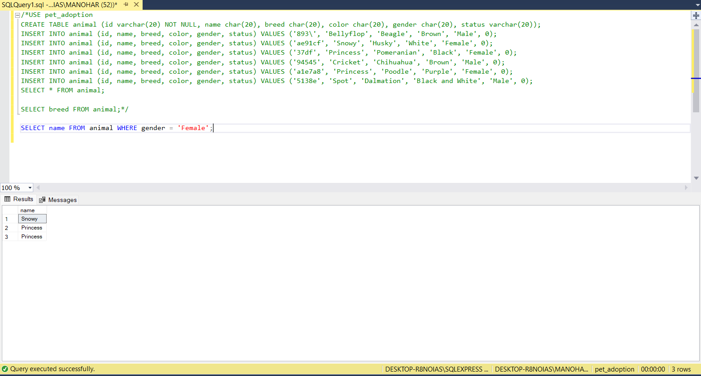

Updating the table animals using update statement and WHERE clause:

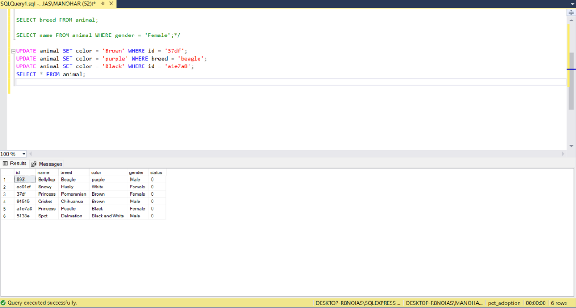

Updating the animal table SET value as ‘1’ using WHERE clause:

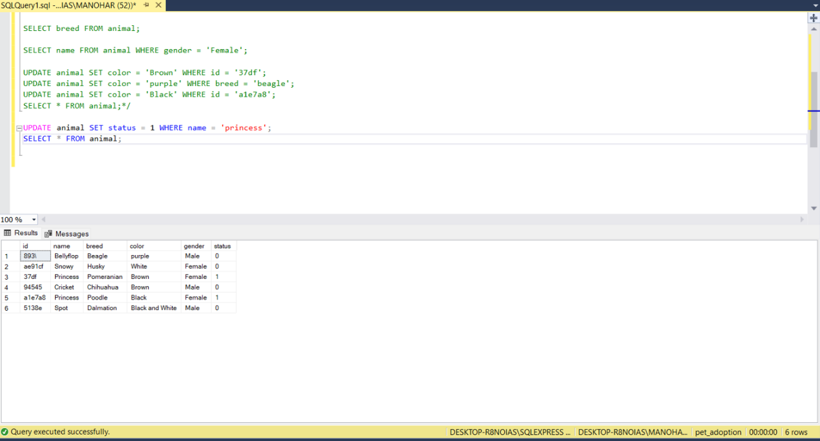

Created another table named ADOPTION and inserted values into it, using **insert** statement.

To view the table using SELECT statement.

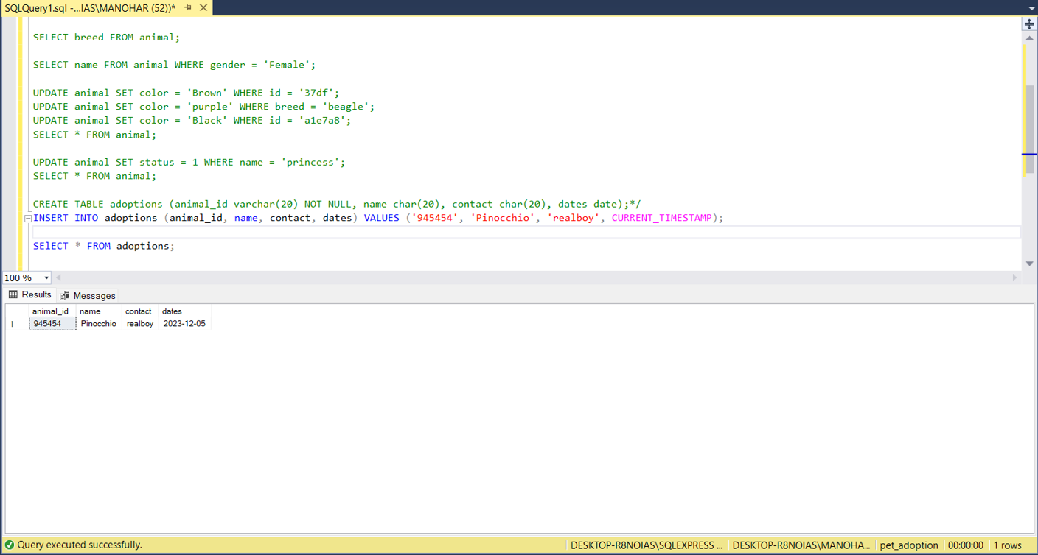

Deleted data using DELETE and WHERE statement:

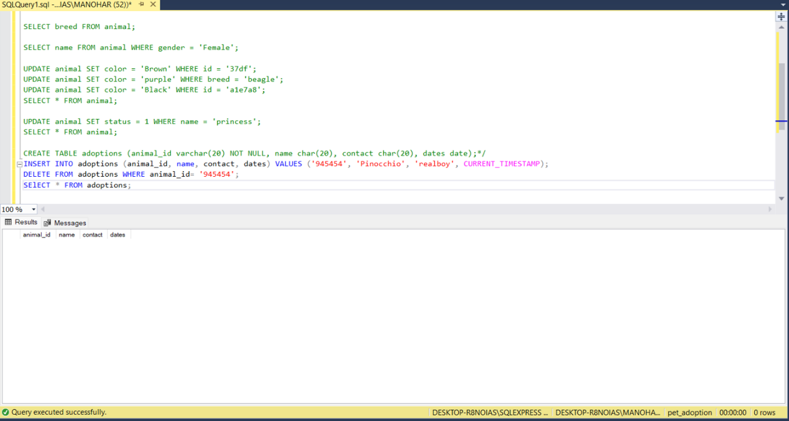

Using of ORDER BY statement:

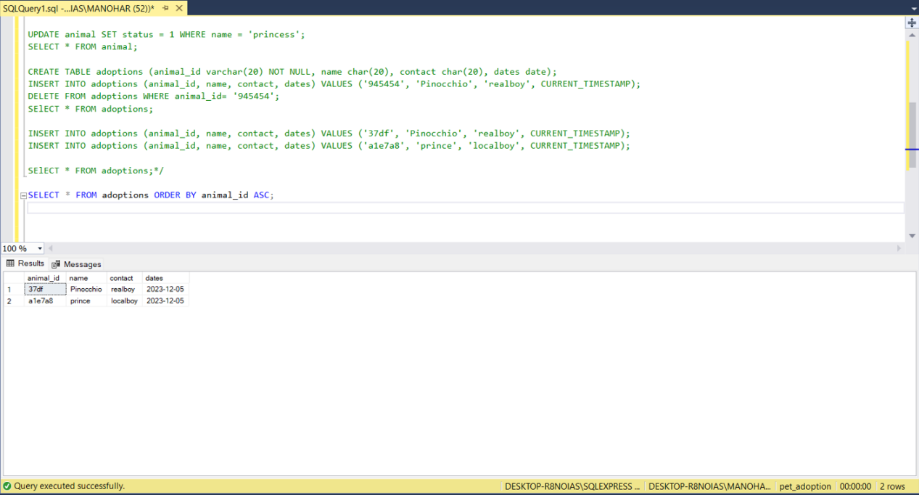

Altering table by adding new columns using ALTER statement.

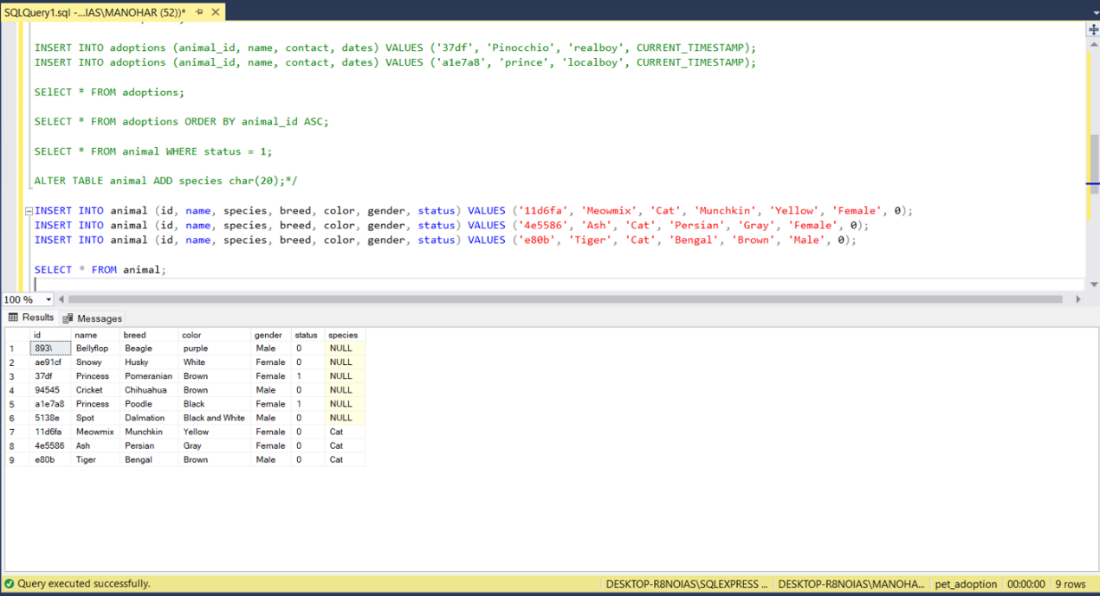

Created a new table called student and inserted data to the table and truncated it. It will delete all the data inside the student table.

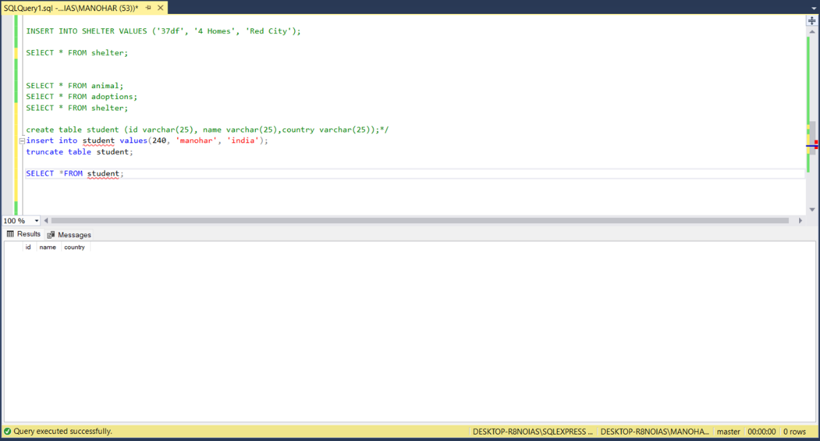

Drop table using DROP statement, it will delete entire table along with the data.

